**PROJECT NAME**

**SAFEX.PYBOTS**

Exchanging of Industrial Safety using NLP based Python Bots

**TEAM NAME**

**SAFEX.PYBOTS**

**TEAM MEMBERS:**

**1)**

**2)**

**3)**

**4)**

**5)**

**INTERIM REPORT OF CAPSTONE PROJECT ON NLP2 – CHATBOT**

**PROJECT OBJECTIVE:**

Design and build chatbot by employing ML/DL techniques which can help the professionals in determining the potential level and accident level involved in any accident and to highlights the safety risk as per the incident description.

**PROBLEM STATEMENT AND ABSTRACT:**

For enhancing one’s self-esteem, wellbeing, and social mobility, work is very important. However, during work activities if any accidents occurred leads to impairments to worker’s health and which in-turn leads to serious social and economic repercussions.

Globally, it is estimated between the range of 1.8% to 6.0% cost of work-related accidents and ill-health out of gross domestic product. It is also estimated as, around 2.3 million people will die in a year around the world due to work-related activities. Specifically, in Brazil, around 2500 such deaths per year which corresponds to one death for every 3.5hr.

Since human activity is involved, accidents & injuries are common despite all the safety measures and precautions put in place. Such injuries can also prove fatal. Industrial accidents can turn depending on the type of industry. For example, a mere spark in a firecracker factory can burn the whole plant leading to loss of lives and property. Workplace injuries are a big concern for both workers and management. It is imperative to classify industrial incidents into different categories and determine whether the event was merely an accident, due to negligence or by incompetence. This avoids reoccurrences, reduce frequency of occurrence & severity and minimize the effects. To achieve this, we employ exploratory data analysis on a dataset from one of the biggest Brazilian industries and find out the top reasons for industrial accidents, nature of accidents, type of employees being injured and so on. We also aim to develop a chatbot application using natural language processing to classify the accident into various critical risks by looking at the description of the accident.

**DOMAIN:**

Industrial safety. NLP based Chatbot.

**DATA DESCRIPTION:**

This The database is basically records of accidents from 12 different plants in 03 different countries which every line in the data is an occurrence of an accident.

**Columns description:**

‣ Data: timestamp or time/date information

‣ Countries: which country the accident occurred (anonymised)

‣ Local: the city where the manufacturing plant is located (anonymised)

‣ Industry sector: which sector the plant belongs to

‣ Accident level: from I to VI, it registers how severe was the accident (I means not severe but VI means very severe)

‣ Potential Accident Level: Depending on the Accident Level, the database also registers how severe the accident could have been (due to other factors involved in the accident)

‣ Genre: if the person is male of female

‣ Employee or Third Party: if the injured person is an employee or a third party

‣ Critical Risk: some description of the risk involved in the accident

‣ Description: Detailed description of how the accident happened

**LINK FOR THE DATASET**

[**Industrial Safety and Health Analytics Database | Kaggle**](https://www.kaggle.com/datasets/ihmstefanini/industrial-safety-and-health-analytics-database)

**DATA INTERPRETATION**

Based on the entire dataset -

1. Shape and Top 5 details

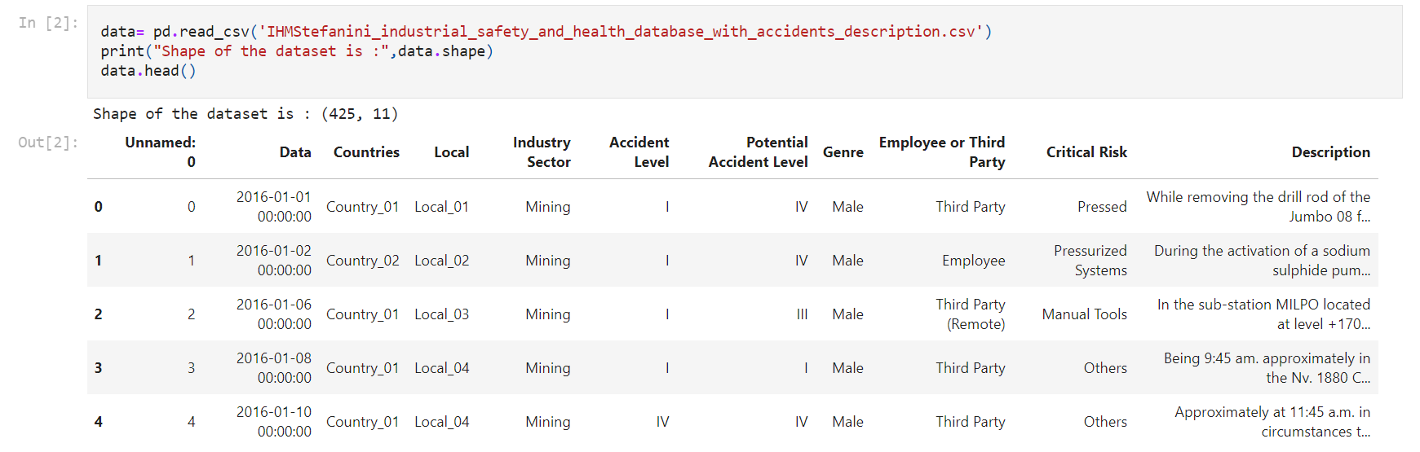

The dataset contains 425 instances and 11 attributes

1. Missing Values

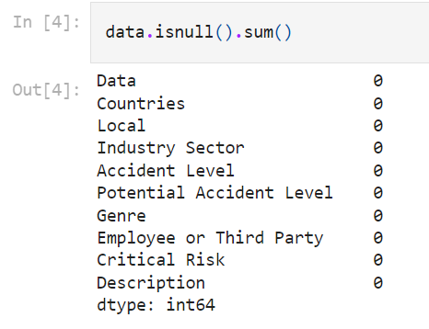

There are NO NULL values

1. Checking of Duplicates and Drop if any-
2. Checking of dtypes and data info

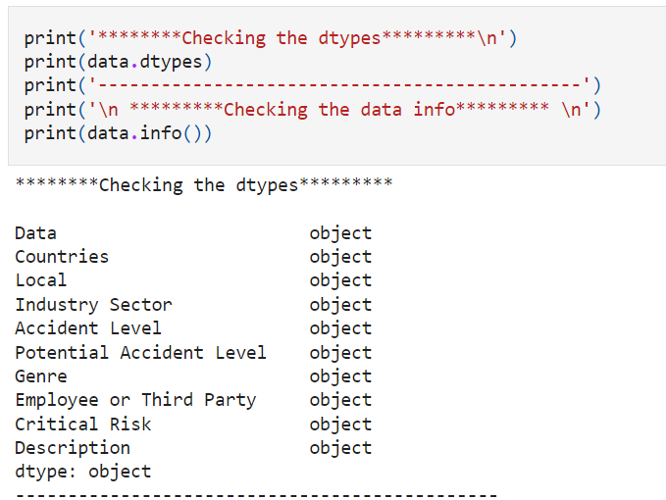

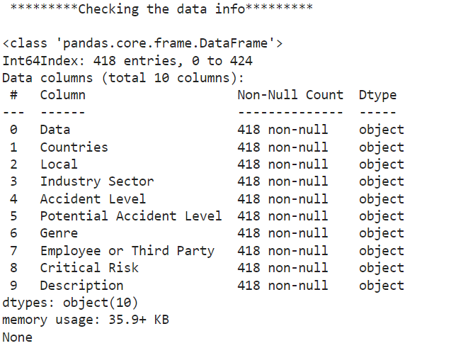

**UNIVARIATE ANALYSIS:**

1. COUNTRY

COUNT PLOT-

It is used to show the counts of observations in each categorical bin using bars. For instance, the count plot () method is used to display the number of accidents happened in country_01, country_02 and country_03 for the country variable.

The following are the observations that are made for the country count plot ()-

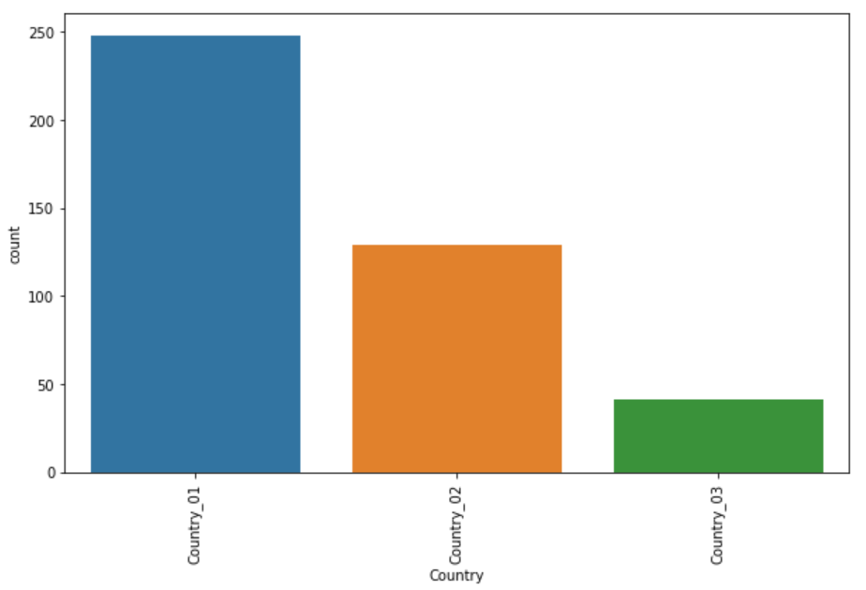

1. About 250 accidents have happened in the country _01.

2. About 125 accidents have happened in the country_02 and about 50 accidents happened in country_03.

3. The maximum number of accidents happened in Country_01 and least number of accidents happened in Country_03.

PIE CHART-

A pie chart represents data in a circular graph containing slices of different colours. It is used to study the proportion of numerical data. It shows the proportion of data as a percentage of a whole. For instance, the pie chart for the country variable gives the number and percentage of accidents that have occurred in the country_01, country_02 and country_03.

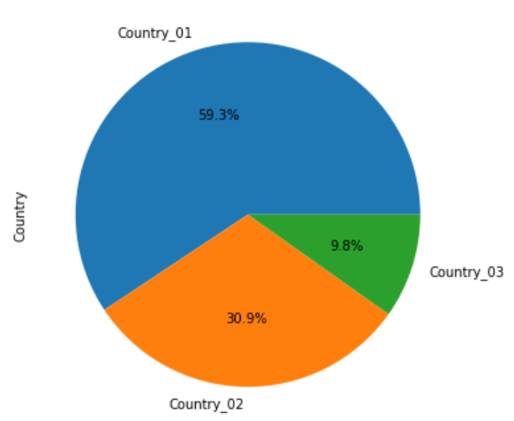

OBSERVATIONS-

1. The number of maximum accidents have taken place in country_01. i.e.- 59.3%.

2. The least number of accidents took place in country_03. i.e- 9.8% .

HISTPLOT-

It is used to show the distribution of the datasets. For instance, for the variable country it displays the number of accidents that happened in the country_01, country_02 and country_03.

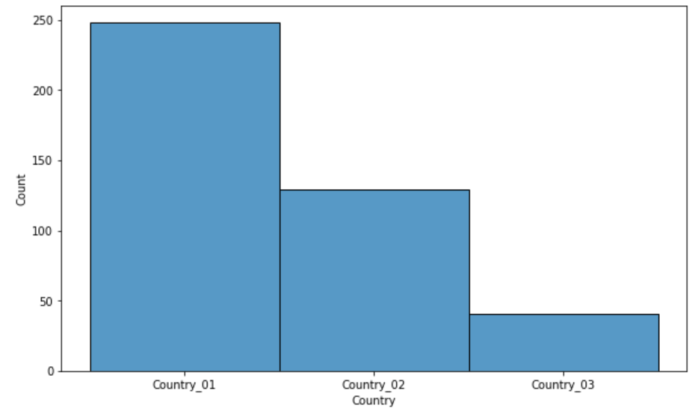

OBSERVATIONS- It can be noted that country_01 has the maximum number of accidents with a count of 248 and the minimum number of accidents has happened in country_03 with a count of 41.

2. LOCAL-

COUNT PLOT-

The local variable determines the region of the accident. The countplot() method helps to calculate the number of accidents happened in region wise.

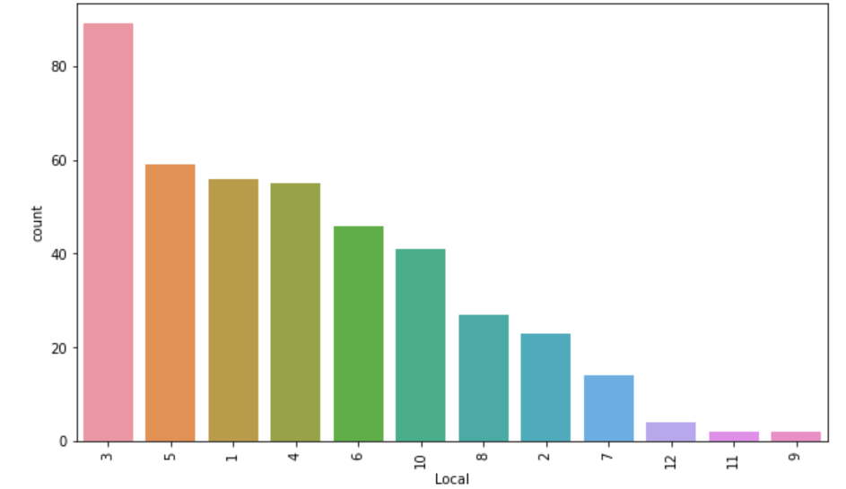

OBSERVATION-

1. It is observed that in the local_03 has the maximum number of accidents with a count of about 90.

2. The least number of accidents happened in the local_09 region.

PIECHART-

The pie chart for the local variable gives the number and percentage of accidents that have occurred in the local_01, local_02 and so on upto local_11

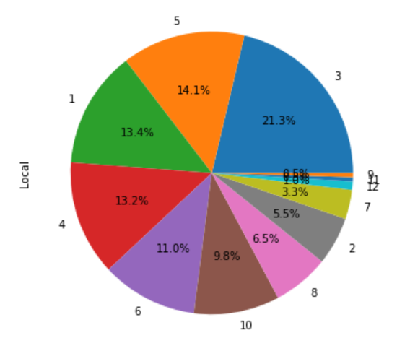

OBSERVATIONS-

1.From the pie chart it can be observed that at the local _03 maximum number of accidents have taken place with about 21.3%.

2. The least number of accidents have happened in local_09. i.e-0.5%

HISTPLOT-

The histplot() of the local variable is useful to determine the distribution.

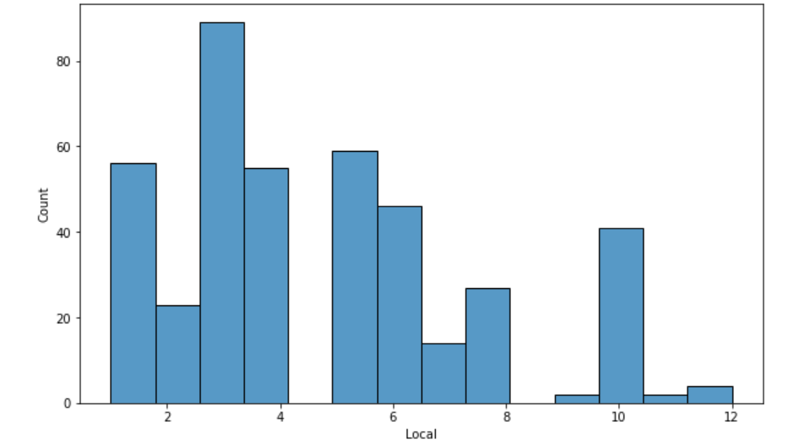

OBSERVATIONS-

1. It is observed that the number of accidents at local_03 is about 90.

3.INDUSTRY SECTOR-

COUNTPLOT-

A countplot() method in industrial sector is used to determine the number of accidents that had happened due to different industrial sectors such as mining, metals and others.

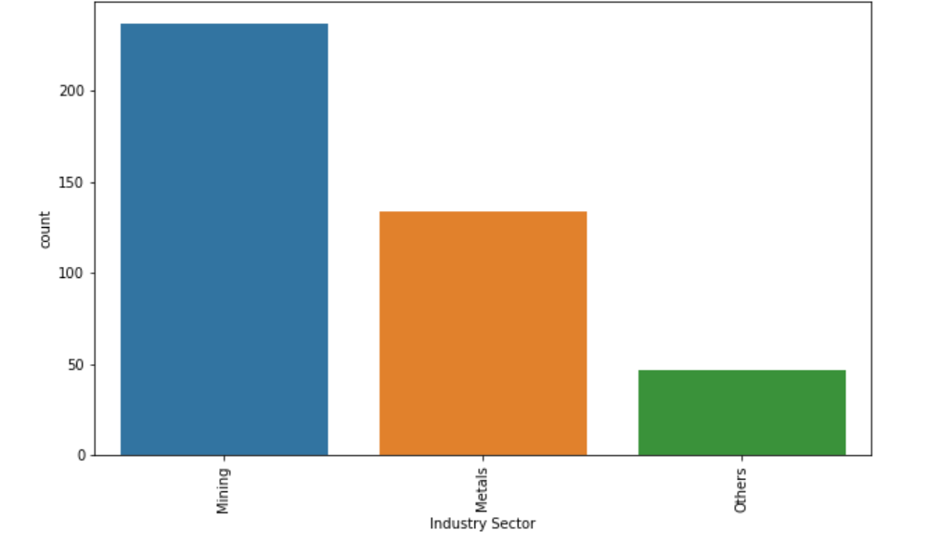

OBSERVATIONS-

1. It can be determined that maximum number of accidents happened due to mining sector (237) than metals and others.

PIECHART-

A piechart is used to determine the percentage of accidents that were caused due to mining, metals and other industrial sector.

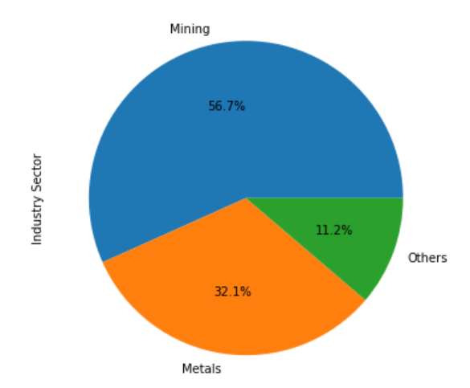

OBSERVATIONS- It can be concluded that the maximum number of accidents happened due to mining i.e- 56.7% of the total accidents.

HISTOGRAM-

A histplot is used to determine the distribution of different industrial sectors.

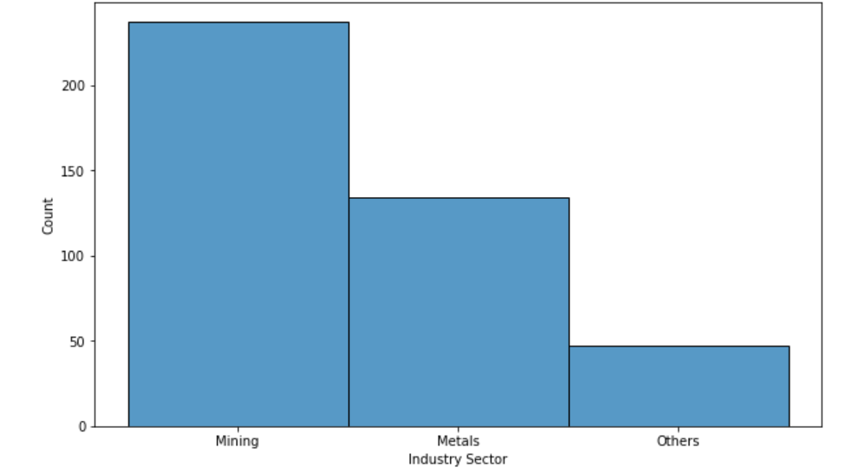

OBSERVATIONS- It can be noted that maximum number of accidents happened due to mining sector.

ACCIDENT LEVEL-

The accident level provided the information about the severity of the accident. Where, I represents less severity and V represents high severity.

COUNTPLOT- The countplot() of the accident level determines the number of accidents that has happened at level I, II, III, IV, and V.

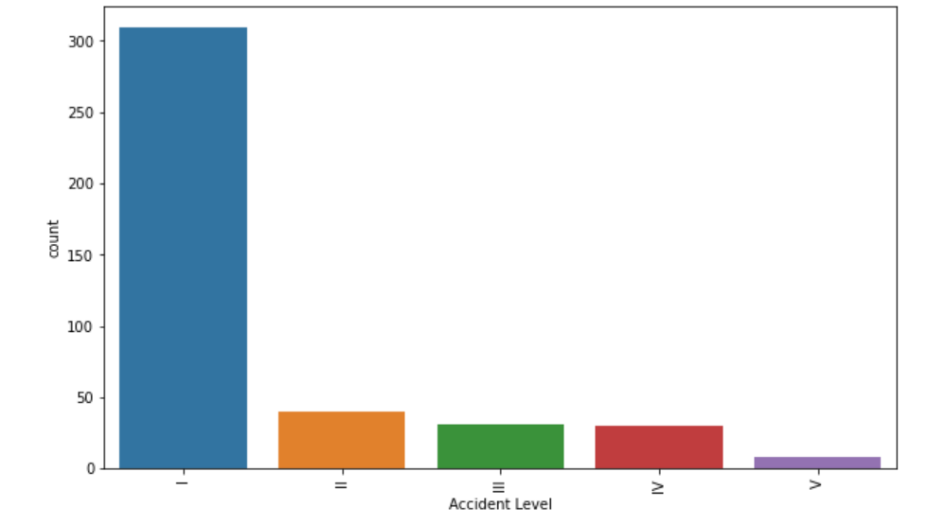

OBSERVATIONS-

1. It can be observed that the number of accidents happened at level I (300)are higher than level V(less than 50).

2. Hence, it can be concluded that maximum number of less severe accidents took place.

PIE CHART-

The pie chart helps to find out the percentage of accident level I, II, III, IV and V accidents out of all the accidents.

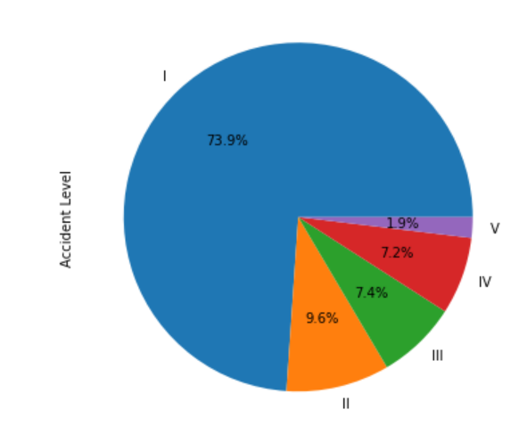

OBSERVATIONS-

1. It can be noted that maximum percentage of less severe accidents took place. i.e accident level I with 73.9%.

HISTOGRAM-

The histogram plot could be used to plot the distribution of accident level I, II, III, IV and V.

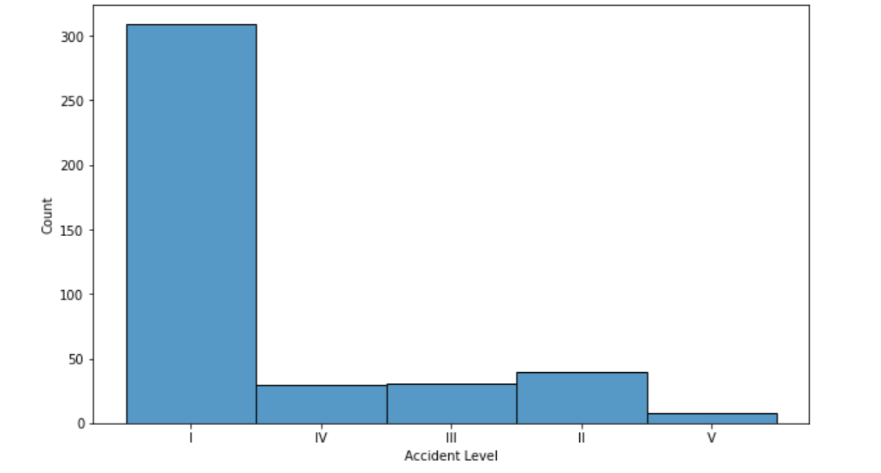

OBSERVATIONS- The number of accidents with less severity(309) are higher than more severity(8) with a huge difference.

POTENTIAL ACCIDENT LEVEL-

The potential accident level is based on the accident level with other factors. Here, Potential accident level I is less severe and VI is more severe.

COUNT PLOT- It determines the number of potential accident level caused by all levels.

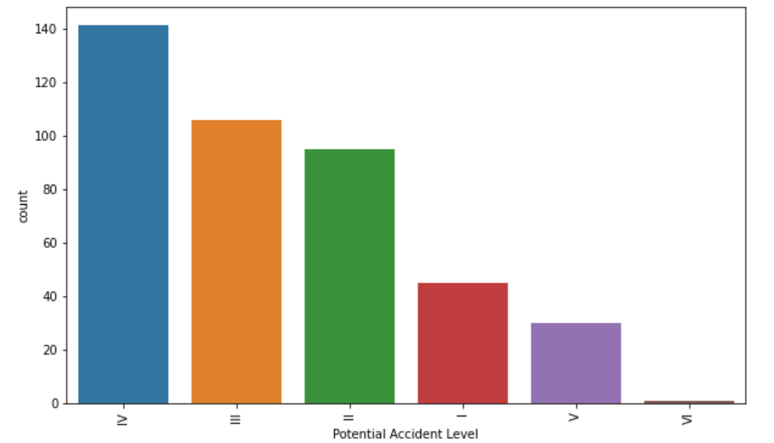

OBSERVATIONS-

The number of accidents due to potential accident level IV are maximum with a count of 141.

PIECHART-

The pie chart determines the percentage of potential accidents caused by level I to VI.

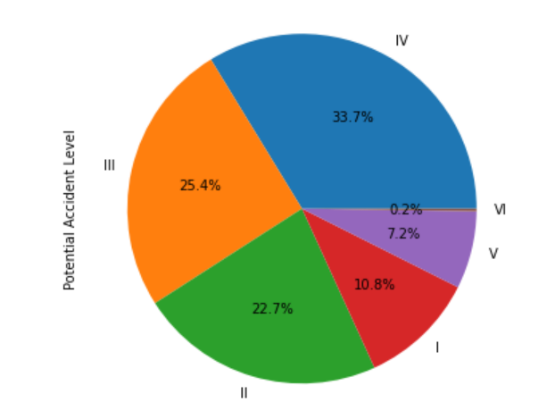

OBSERVATIONS- It can be determined that the percentage and number of accidents caused due to potential accident level IV are maximum.

HISTOGRAM-

It gives the distribution of the potential accident level.

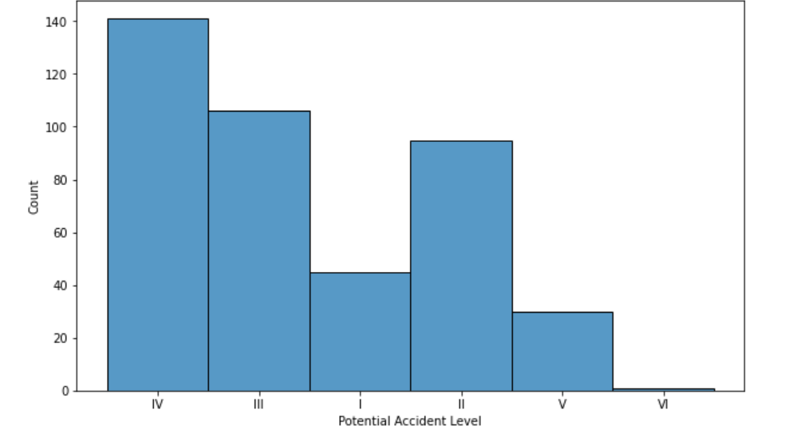

OBSERVATIONS-

It can be determined that the number of accidents caused by potential accident level IV are maximum.

6. GENDER-

The gender is used to determine the number of accidents caused to both female and male.

COUNTPLOT-

The countplot() is used to

